Level 3 Science Industry Maintenance Technician Apprenticeship
Syngenta’s Advanced Apprenticeship Programme offers fantastic opportunities including a chance to earn while you learn. You will emerge with valuable qualifications and a wealth of experience that will open doors to a career in a world-class company.
What opportunities are available?
An opportunity is available at our award-wining Huddersfield Manufacturing Centre on the Level 3 Science Industry Maintenance Technician (SIMT) standard working alongside a world class team maintaining complex computer controlled manufacturing plant that provides engineering services to the Huddersfield Site 24/7 365 days a year.
Your role will be to maintain complex manufacturing plants to the highest safety, health and environmental standards and ensure they are available to deliver on promises we have made to the business.
You will be involved with preventative maintenance, planned maintenance, project work and breakdown response.
Entry criteria
To be considered for the opportunity listed above, you will need;
- 3 GCSE A*-C (Level 4-6 equivalent) including Science and ICT and/or Technical subjects
- GSCE Grade B (Level 5-6 equivalent) in Mathematics and English
You must also be a motivated and pro-active self-starter who can work as part of a team and can demonstrate good technical aptitude
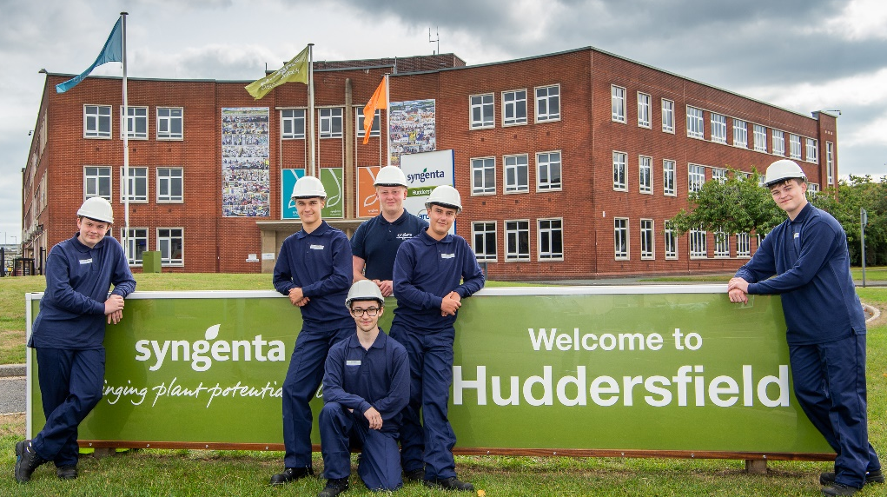
How do I apply?
To find out more information and to apply, please visit www.syngenta.co.uk/careers

