Level 3 Science Manufacturing Apprenticeship
Syngenta’s Advanced Apprenticeship Programme offers fantastic opportunities including a chance to earn while you learn. You will emerge with valuable qualifications and a wealth of experience that will open doors to a career in a world-class company.

What opportunities are available?
An opportunity is available at our award-wining Huddersfield Manufacturing Centre on the Level 3 Science Manufacturing working alongside a world class team operating computer controlled manufacturing plant.
Your role, as part of a flexible team, will be to operate manufacturing plants to the highest safety, health and environmental standards, in support of the Huddersfield site manufacturing plan. You will be involved in operating and monitoring complex process control systems for manufacturing plant processes and carrying out analysis activities and basic first line maintenance.
Entry criteria
To be considered for the opportunity listed above, you will need;
- 3 GCSE A*-C (Level 4-6 equivalent) including Science and ICT and/or Technical subjects
- GSCE Grade B (Level 5-6 equivalent) in Mathematics and English
You must also be a motivated and pro-active self-starter who can work as part of a team and can demonstrate good technical aptitude
How do I apply?
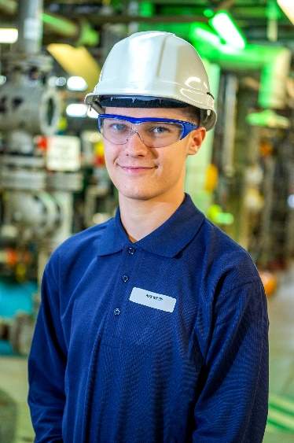
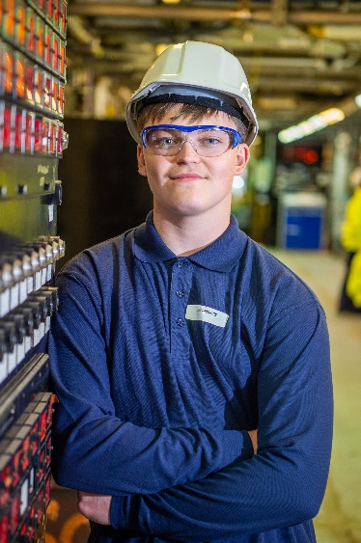
To find out more information and to apply, please visit www.syngenta.co.uk/careers
