COMPLETE YOUR FORM CONTACTLESS ONLINE BY SCANNING THE QR CODE ON THE BACK OF THIS FORM

PLEASE COMPLETE APPLICATION FROM USING BLOCK CAPITALS
YOUR DETAILS
FIRST NAME
LAST NAME
DATE OF BIRTH |  | DAY | MONTH | YEAR
GENDER (Please circle) |  | MALE | FEMALE | Prefer not to say
CURRENT SCHOOL
CURRENT YEAR GROUP |  | (Please circle) 8 9 10 11 12 13 14
EMAIL ADDRESS
MOBILE NUMBER
HOME PHONE NUMBER
HOME ADDRESS
(House no. and road name.)
CITY
POST CODE
PARENT/CARER DETAILS
FULL NAME
EMAIL
MOBILE NUMBER
FAVOURITE SPORT
3 YEAR GOAL | UNIVERSITY | APPRENTICESHIP | GLOBAL COACHING | PLAYING SCHOLARSHIP
INSTAGRAM USERNAME

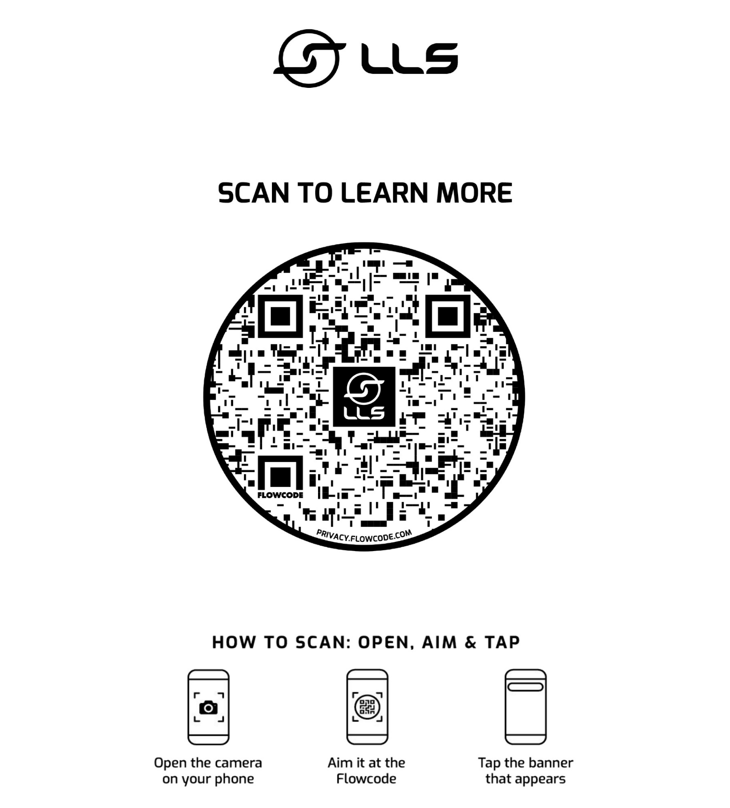
By completing this form and submitting it to a member of LLS staff you agree for your data to be used for marketing purposes by LLS and its associated partners, in line with LLS’ data protection and privacy policy. Your data will never be supplied to any third party without your prior consent. If you would like to view the policy or have any questions about how your data will be used please contact us on 01512943229.
Please hand this form back to a member of LLS staff or send by email to yourfuture@llsonline.uk / Instagram DM to LLSonline
COMPLETE YOUR FORM CONTACTLESS ONLINE

